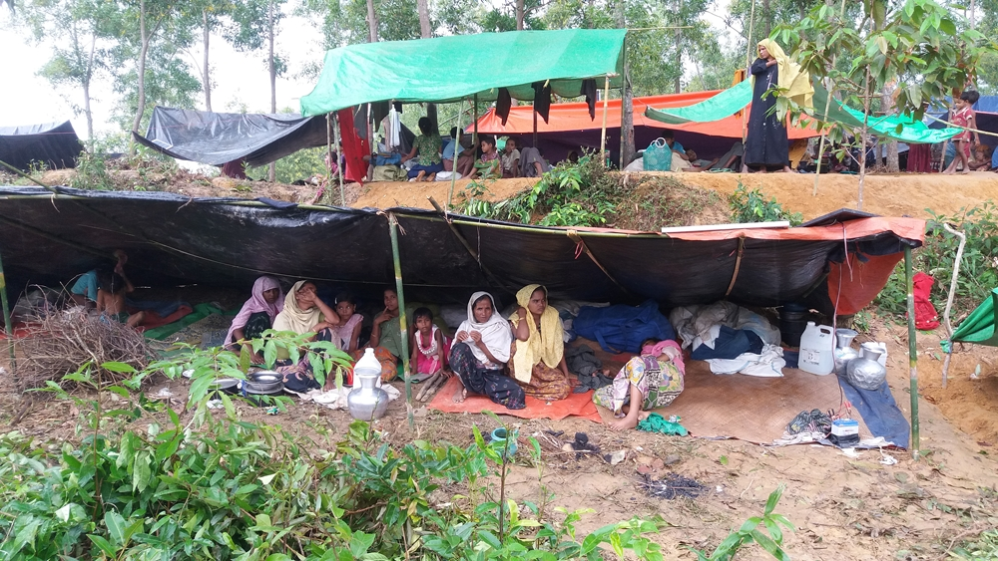
Rohingya Crisis in Cox’s Bazar (Update)

14 September: Near about 400,000 Rohingya have fled across the border into neighboring Bangladesh. Part of them have so far taken temporary shelters in different shelters in Ukhia and Teknaf of Cox’s Bazar and most of them have taken shelters in various villages nearby. It is observed that the Rohingya people are fully dependent on food assistance and basic items. There is scarcity of appropriate source of drinking water and also sanitation situation is in dire position. Many of them are still living under the open sky.

More than 200,000 Rohingya children who have fled to Bangladesh from Myanmar are at incredible risk and they need urgent support. It is to be noted that sixty percent of all refugees are children, according to preliminary data. (Unicef, 12 Sept.)

The Immediate Needs
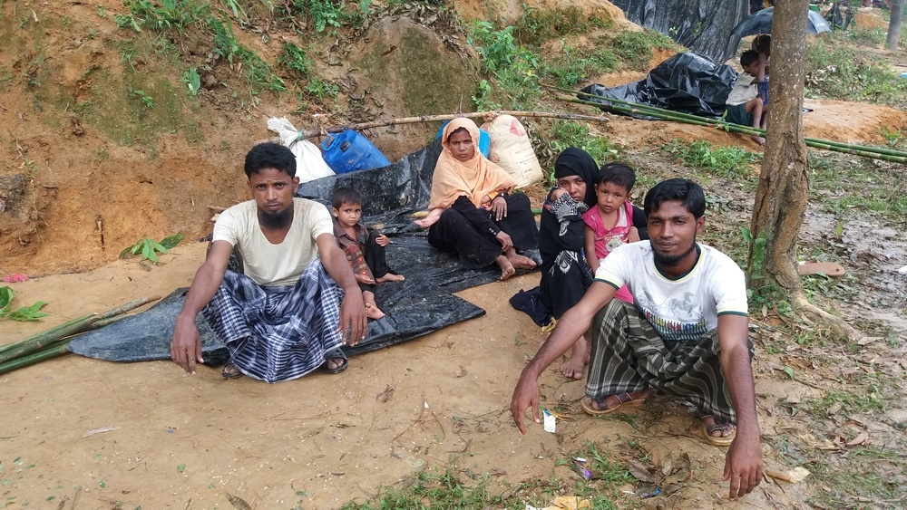
Some identified immediate needs are food, water, food, sanitation, shelter, medicines, measures for child protection.

Government Initiatives

- Over the last few decades, almost half a million Rohingya Muslims have been living in two registered camps and makeshift settlements bordering Cox's Bazar, fleeing persecution and communal violence. Government has already taken plan to build one new camp in Tyingkhali near the Bakukhali camp to accommodate newly arrived Ruhibgya refugees.

- Government and local union parisahd have so far set up nine tube-wells in Gomdom Rohingya camp for providing drinking water.

- Registration of Rohingya families using biometric system has been officially started at Rohingya camp in Ukhia's Baluchali on 11 Septermber,Monday, 2017, noon.

- Prime Minister Sheikh Hasina visited the Kutupalong Rohingya refugee camp in Ukhia upazila of Cox's Bazar on 12 Sept. During the visit she said, ‘Bangladesh would offer the refugees temporary shelter and aid, but that Myanmar should soon "take their nationals back."

- Diplomats of 46 countries, comprising ambassadors and high commissioners, visited the Kutupalong and Balukhali Rohingya camps and interacted with Rohingya refugees on 13 September.

Other Support:
Some NGOs and local people are providing food, water, cash, but almost all of these initiatives are going on in a scattered way. Bangladesh Border Guards are providing some medicines. Local community people are also providing support with dry foods, bamboo for making shelter etc. They are also helping them to reach the nearby shelters.
Diplomats of 46 countries, comprising ambassadors and high commissioners, visited the Kutupalong and Balukhali Rohingya camps and interacted with Rohingya refugees on 13 September.
Caritas Initiatives:
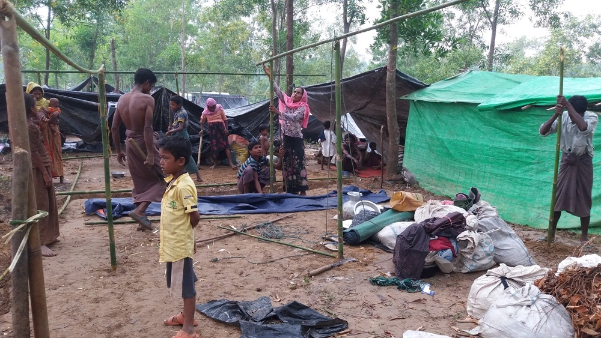
Caritas Bangladesh have planned to distribute food and non-food items among 14,130 Rohingya people with the total budget amount of Tk. 34,457283. Each family will receive 15kg of rice, 2kg of pressed rice, 3kg of dal (pulse), 1kg of salt, 1kg of sugar and 1ltr of edible oil, as well as some home and cooking products such as rice dish, plate, spoon, glass, etc. soon after getting approval from the NGO Affairs Bureau in Bangladesh.

